Azure Security alerts and incidents

What are security alerts?
Security alerts are the notifications generated by Defender for Cloud's workload protection plans when threats are identified in your Azure, hybrid, or multicloud environments.
- Security alerts are triggered by advanced detections available when we enable Defender plans for specific resource types.
- Each alert provides details of affected resources, issues, and remediation steps.
- Defender for Cloud classifies alerts and prioritizes them by severity.
- Alerts are displayed in the portal for 90 days, even if the resource related to the alert was deleted during that time. This is because the alert might indicate a potential breach to your organization that needs to be further investigated.
- Alerts can be exported to CSV format.
- Alerts can also be streamed directly to a Security Information and Event Management (SIEM) such as Microsoft Sentinel, Security Orchestration Automated Response (SOAR), or IT Service Management (ITSM) solution.
- Defender for Cloud leverages the MITRE Attack Matrix to associate alerts with their perceived intent, helping formalize security domain knowledge.

What are security incidents?
A security incident is a collection of related alerts.
Incidents provide you with a single view of an attack and its related alerts, so that you can quickly understand the actions an attacker took, and the affected resources.

What is Microsoft Defender for Cloud?
Microsoft Defender for Cloud is a Cloud Native Application Protection Platform (CNAPP), which is a unified solution that combines multiple cloud security tools to protect applications across their entire lifecycle. The solution provides a comprehensive view of your security posture across your cloud and on-premises resources. It also helps you secure multicloud and hybrid environments and integrates security into DevOps workflows. There are three core components:
- Development Security Operations (DevSecOps) manages code-level security across multicloud and multi-pipeline environments.
- Cloud Security Posture Management (CSPM) checks and improves the security posture of cloud resources.
- Cloud Workload Protection Platform (CWPP) defends workloads such as virtual machines (VMs), containers, storage, databases, and serverless functions from threats.

How does Defender for Cloud detect threats?
To detect real threats and reduce false positives, Defender for Cloud monitors resources, collects, and analyzes data for threats, often correlating data from multiple sources.

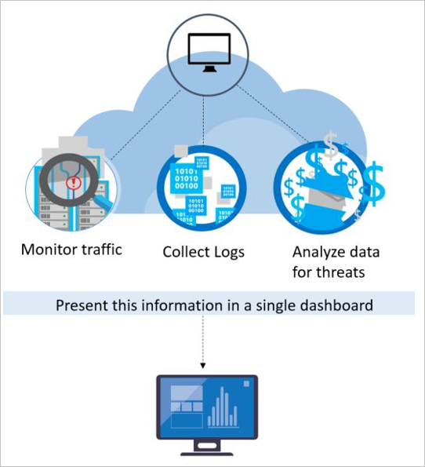

What is the difference between Service Health alerts and security alert in azure?

Service Health alerts notify you of platform-wide Azure issues like outages or maintenance, while security alerts, often from Microsoft Defender for Cloud, focus on vulnerabilities and potential threats affecting your specific Azure resources.
The key difference lies in their scope: Service Health alerts are about the Azure platform itself, while security alerts are about the security posture of your individual services and resources within your subscription.

4. Configure resource group security alerts
- Go to Microsoft Defender for Cloud>Management>Workflow automation and click ‘Add workflow automation’

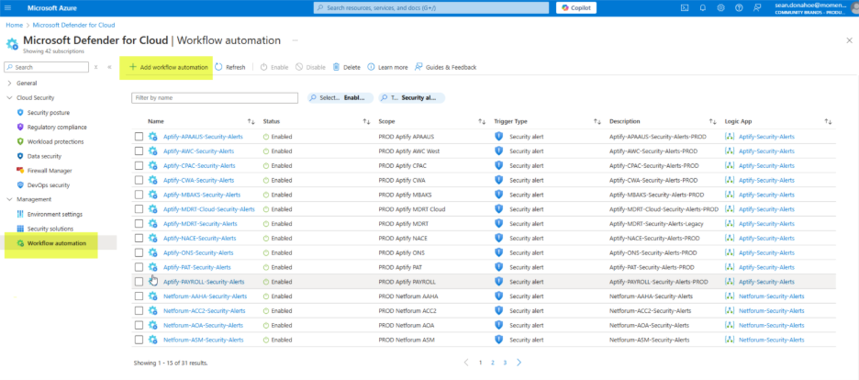
- Name = Netforum-<customer acronym>-Security-Alerts
- Subscription = subscription used for new deployment
- Resource Group = main resource group, ‘SMACNA’ for example
- Defender for Cloud data type = Security alert
- Alert severities = All severities selected
- Actions
- Select PROD IT Operations subscription
- Logic app name = Netforum Security Alerts
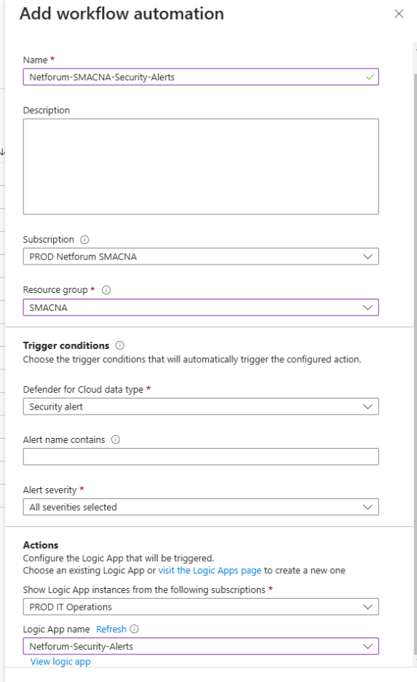
Note: We have to create Logic app for the alert on different subscription or same subscription.
# JSON Schema for manual:
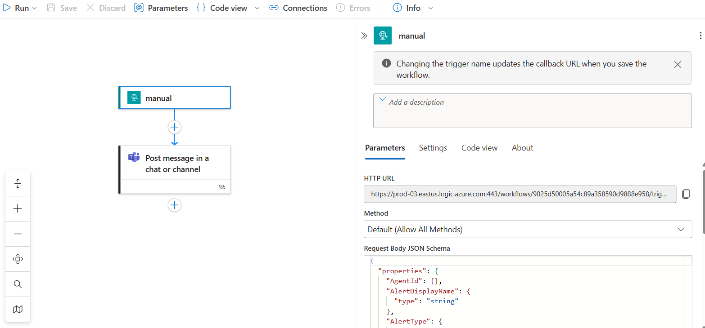
{
"properties": {
"AgentId": {},
"AlertDisplayName": {
"type": "string"
},
"AlertType": {
"type": "string"
},
"AlertUri": {
"type": "string"
},
"AzureResourceId": {
"type": "string"
},
"CompromisedEntity": {
"type": "string"
},
"ConfidenceLevel": {},
"ConfidenceReasons": {},
"ConfidenceScore": {},
"CorrelationKey": {
"type": "string"
},
"Description": {
"type": "string"
},
"EndTimeUtc": {
"type": "string"
},
"Entities": {
"items": {
"properties": {
"$id": {
"type": "string"
},
"$ref": {
"type": "string"
},
"Asset": {
"type": "boolean"
},
"BlobContainer": {
"properties": {
"$ref": {
"type": "string"
}
},
"type": "object"
},
"Category": {
"type": "string"
},
"Etag": {
"type": "string"
},
"FileHashes": {
"items": {
"properties": {
"$ref": {
"type": "string"
}
},
"required": [
"$ref"
],
"type": "object"
},
"type": "array"
},
"Files": {
"items": {
"properties": {
"$id": {
"type": "string"
},
"Asset": {
"type": "boolean"
},
"Directory": {
"type": "string"
},
"FileHashes": {
"items": {
"properties": {
"$id": {
"type": "string"
},
"Algorithm": {
"type": "string"
},
"Asset": {
"type": "boolean"
},
"FriendlyName": {
"type": "string"
},
"Type": {
"type": "string"
},
"Value": {
"type": "string"
}
},
"required": [
"$id",
"Algorithm",
"Value",
"FriendlyName",
"Asset",
"Type"
],
"type": "object"
},
"type": "array"
},
"Name": {
"type": "string"
},
"Type": {
"type": "string"
}
},
"required": [
"$id",
"Directory",
"Name",
"FileHashes",
"Asset",
"Type"
],
"type": "object"
},
"type": "array"
},
"FriendlyName": {
"type": "string"
},
"Metadata": {
"properties": {
"IsGraphCenter": {
"type": "boolean"
}
},
"type": "object"
},
"Name": {
"type": "string"
},
"ResourceId": {
"type": "string"
},
"ResourceName": {
"type": "string"
},
"ResourceType": {
"type": "string"
},
"StorageResource": {
"properties": {
"$ref": {
"type": "string"
}
},
"type": "object"
},
"Type": {
"type": "string"
},
"Url": {
"type": "string"
}
},
"required": [],
"type": "object"
},
"type": "array"
},
"ExtendedLinks": {},
"ExtendedProperties": {
"properties": {
"API type": {
"type": "string"
},
"Alert Id": {
"type": "string"
},
"CompromisedEntity": {
"type": "string"
},
"EffectiveAzureResourceId": {
"type": "string"
},
"EffectiveSubscriptionId": {
"type": "string"
},
"Investigation steps": {
"type": "string"
},
"Malware types detected": {
"type": "string"
},
"Potential causes": {
"type": "string"
},
"ProductComponentName": {
"type": "string"
},
"SHA-256": {
"type": "string"
},
"resourceType": {
"type": "string"
}
},
"type": "object"
},
"Intent": {
"type": "string"
},
"IsIncident": {
"type": "boolean"
},
"ProcessingEndTime": {
"type": "string"
},
"ProductName": {
"type": "string"
},
"ProviderAlertStatus": {},
"RemediationSteps": {
"items": {
"type": "string"
},
"type": "array"
},
"ResourceIdentifiers": {
"items": {
"properties": {
"$id": {
"type": "string"
},
"AadTenantId": {
"type": "string"
},
"AzureResourceId": {
"type": "string"
},
"AzureResourceTenantId": {
"type": "string"
},
"Type": {
"type": "string"
}
},
"required": [
"$id",
"Type"
],
"type": "object"
},
"type": "array"
},
"Severity": {
"type": "string"
},
"StartTimeUtc": {
"type": "string"
},
"Status": {
"type": "string"
},
"SystemAlertId": {
"type": "string"
},
"TimeGenerated": {
"type": "string"
},
"VendorName": {
"type": "string"
},
"WorkspaceId": {},
"WorkspaceResourceGroup": {},
"WorkspaceSubscriptionId": {}
},
"type": "object"
}
# JSON Schema for Post message in a chat or channel:

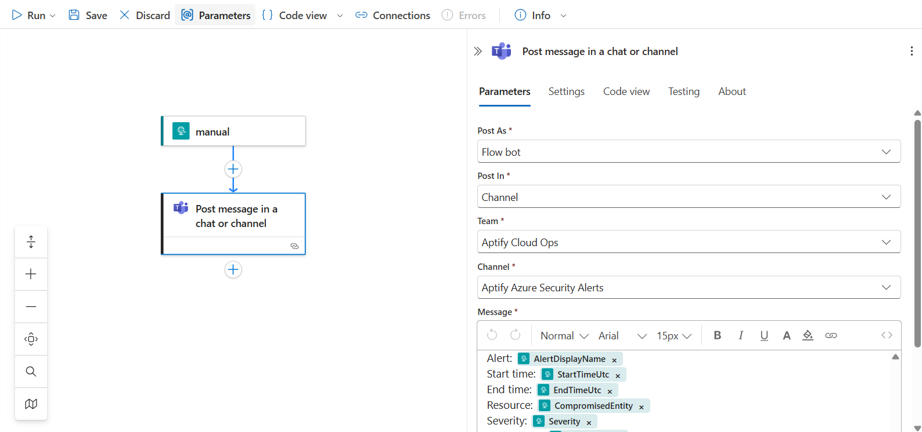
Alert: AlertDisplayName
Start time:StartTimeUtc
End time: EndTimeUtc
Resource:CompromisedEntity
Severity: Severity
Description: Description
# Need to setup connection to send Alert.

